**Customer Manual Guide**

**Home**

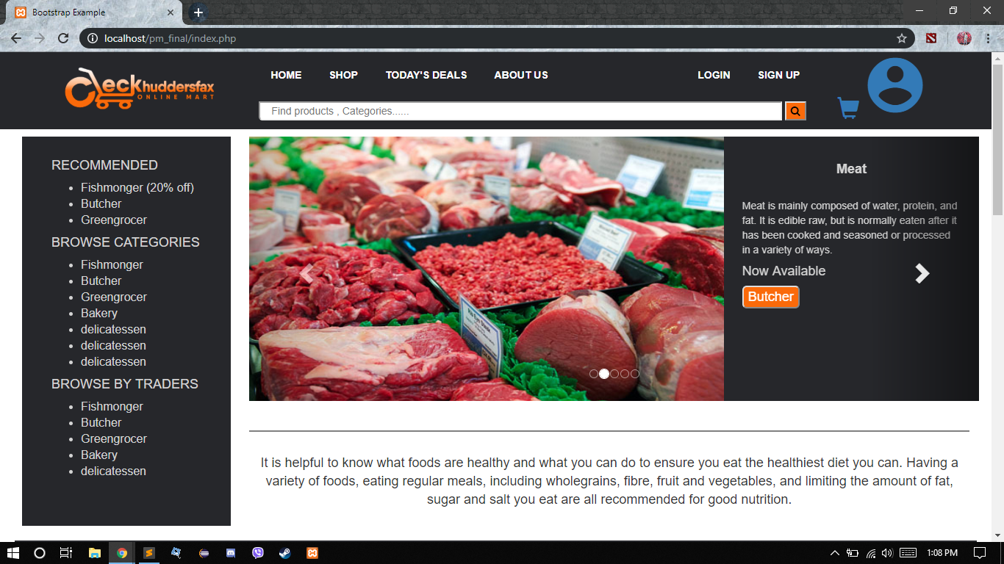

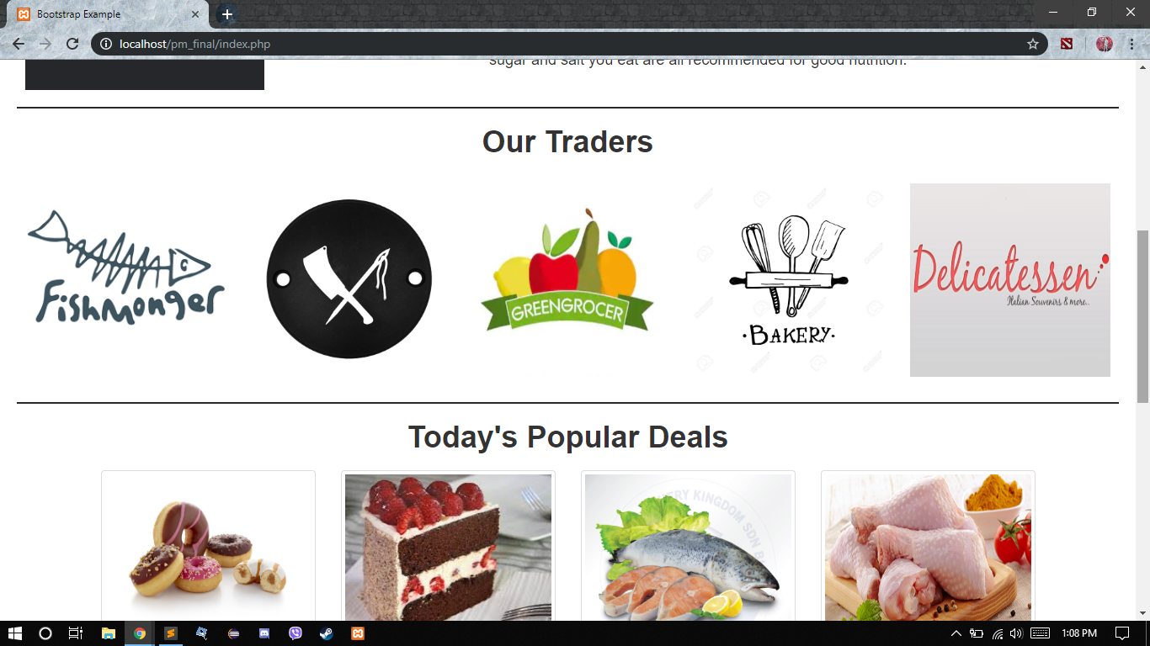

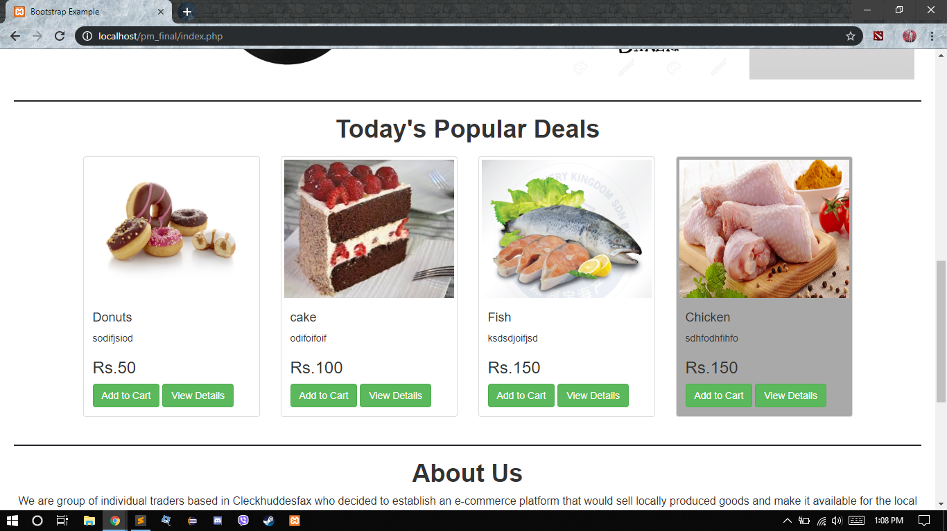

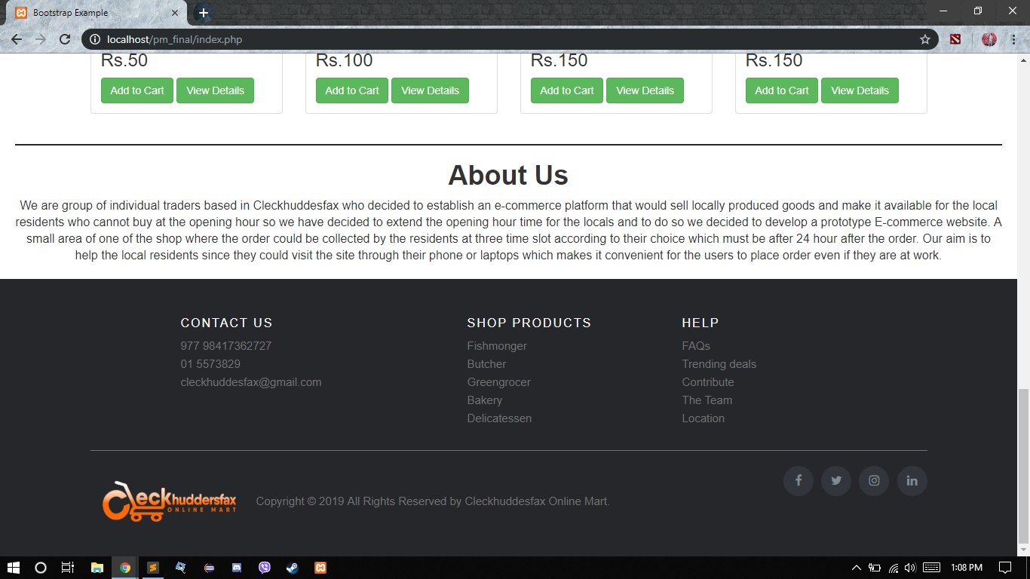

**This is our main panel it includes all product items that are shown in the main panel. The items of five traders: Butcher, Fish monger, Bakery, Green Grocer, Delicatessen; are displayed in this page.**

**Register**

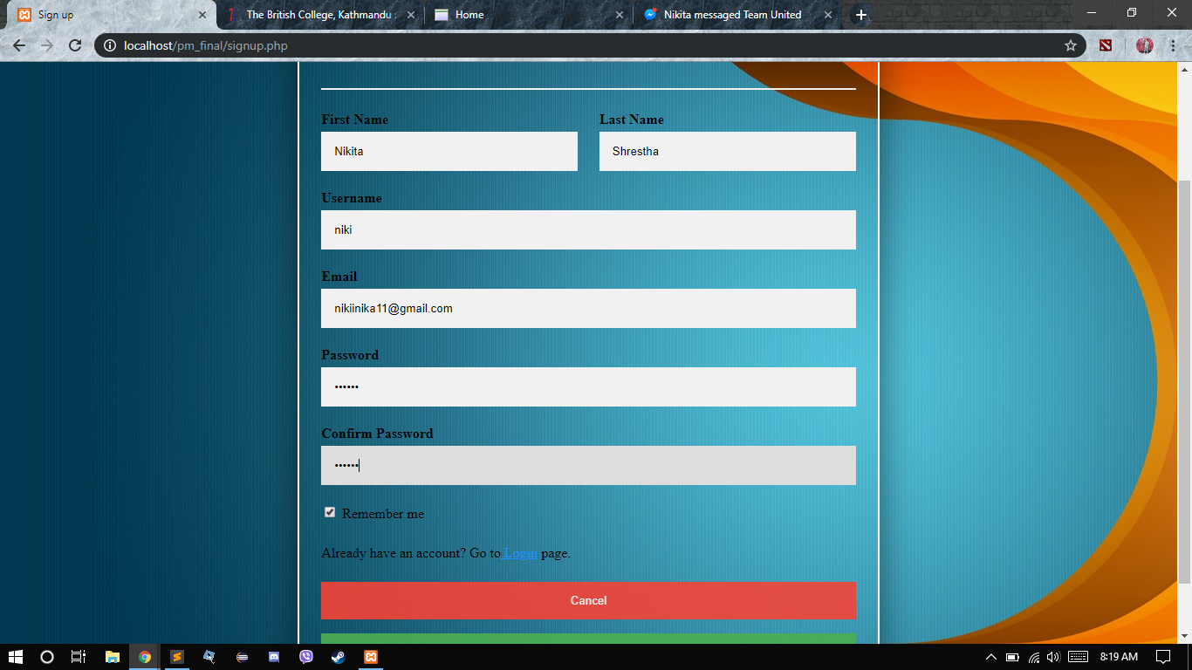

**The customer can register themselves by filling up their details which include first name, last name, username, email, and password and confirm password and sign up.**

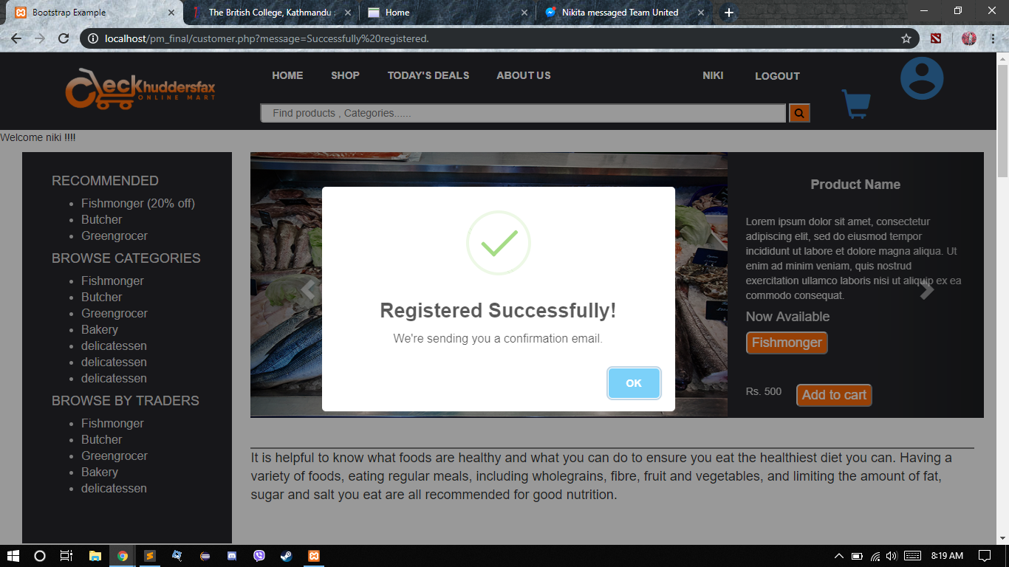

**When you have registered the message will pop up that is “Registered Successful”.**

**Verification**

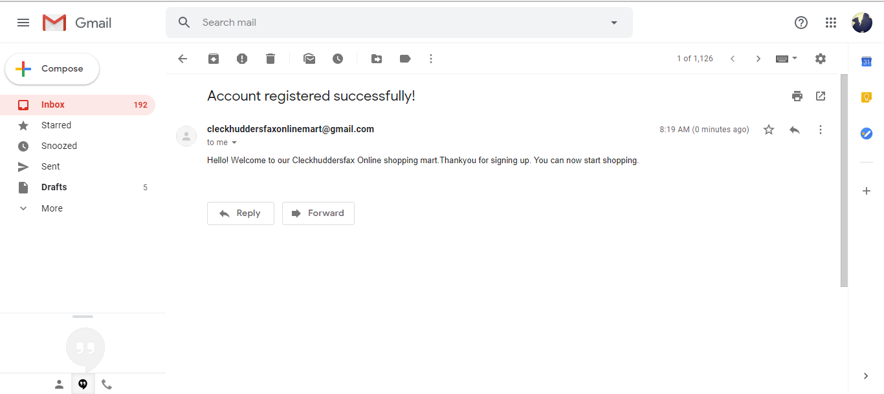

**Customer will receive a mail via *Cleckhuddersfax* after successful registration.**

**Shop**

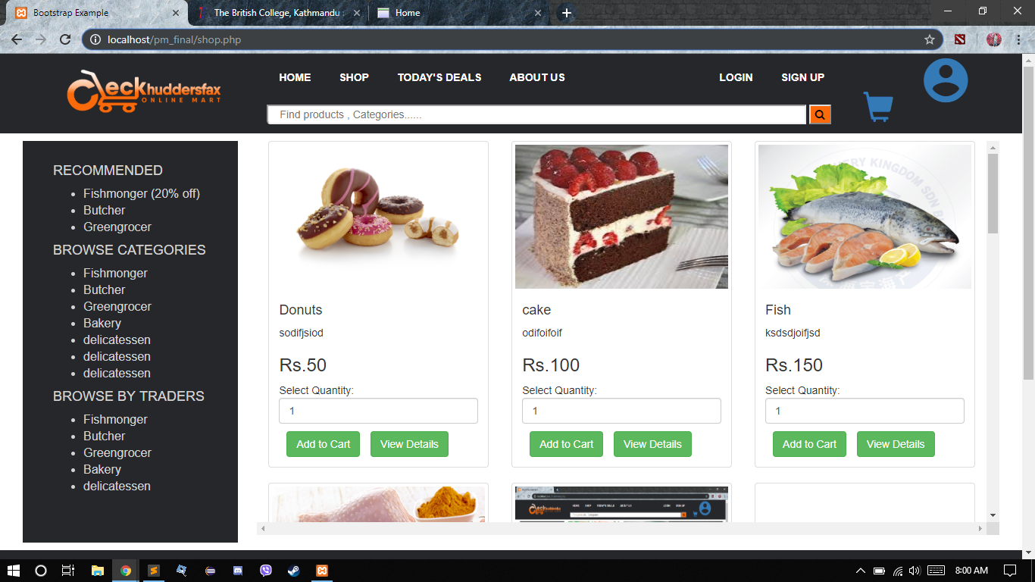

**Customer can find all items of all the traders in shop page. You can get the price ,view details of the items, Select Quantity and Add to cart option in this page.**

**Shopping Cart**

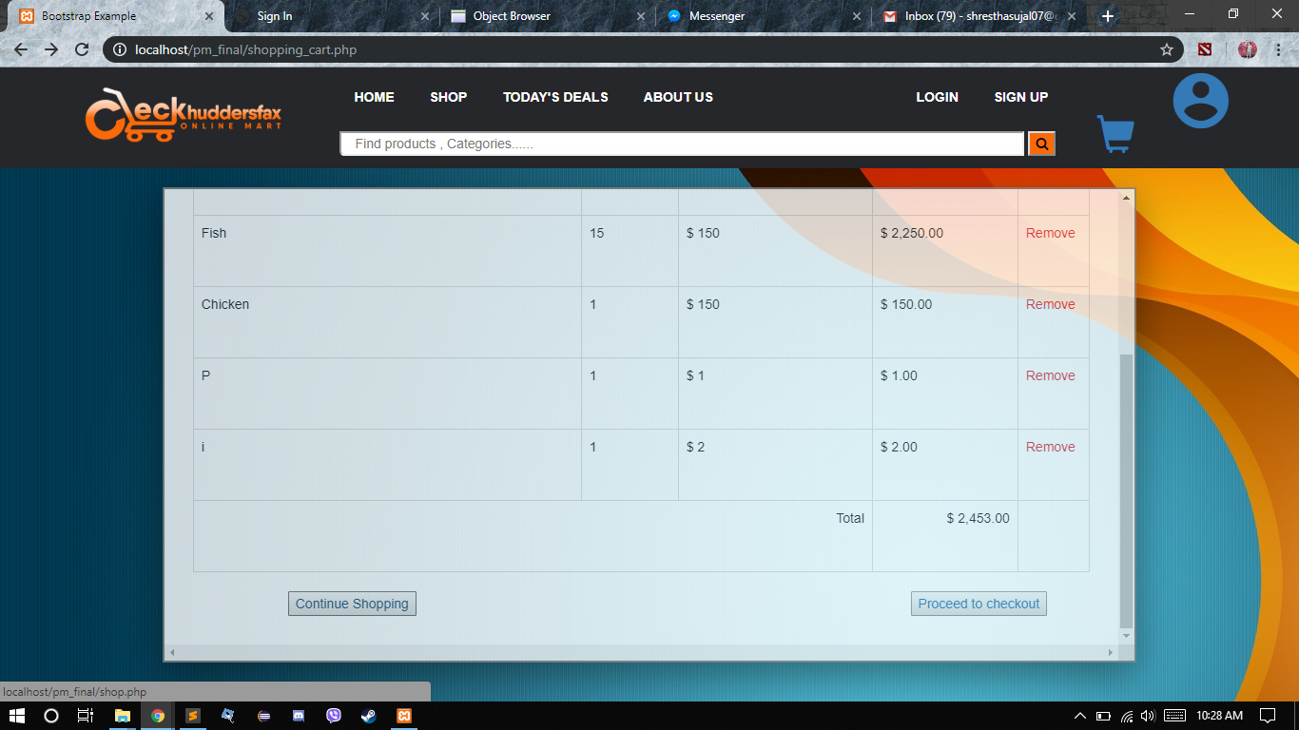

**After you select the item and quantity then you will see this page. Here you will find the items that you have selected and you proceed to checkout through single payment method.**

**About Us**

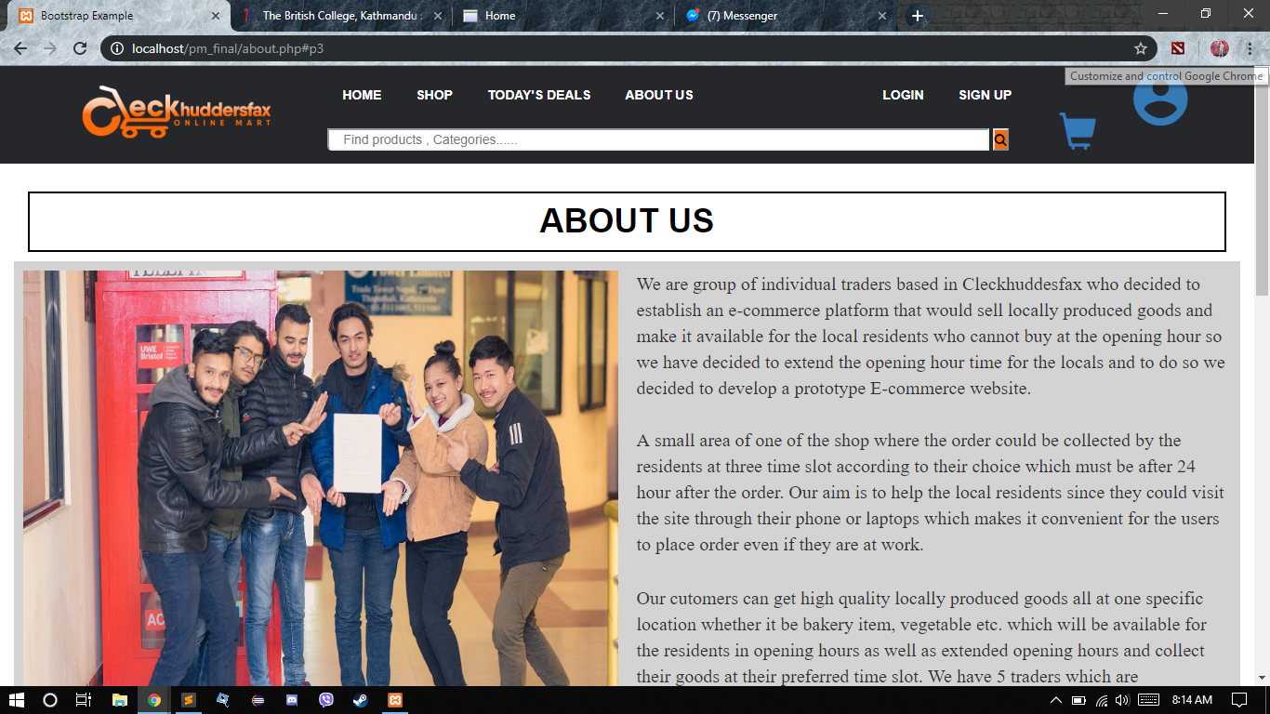 

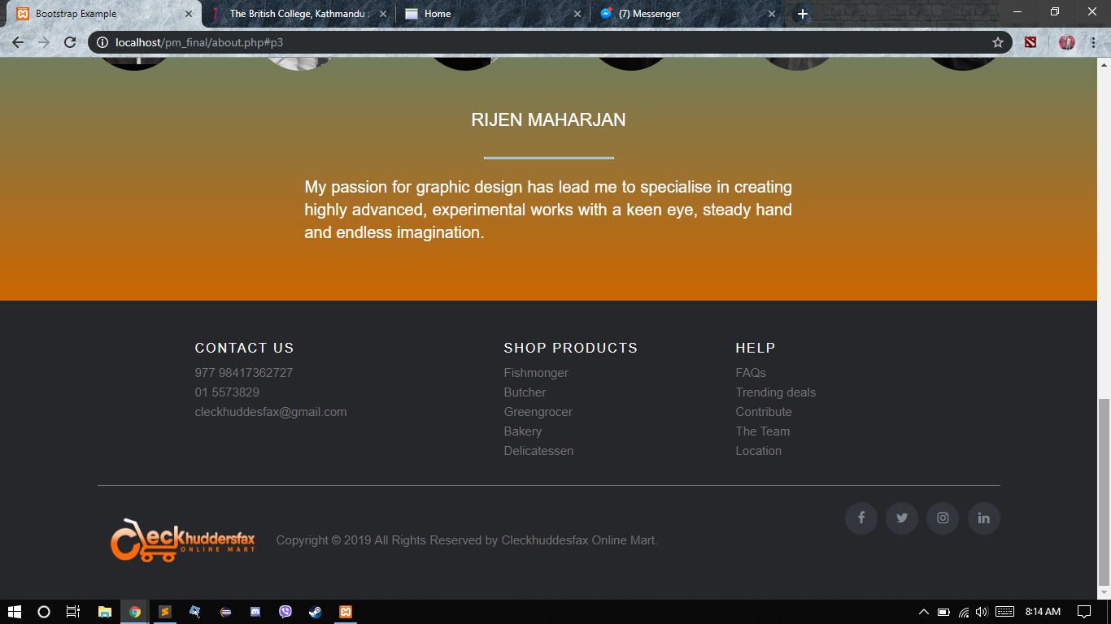

**About us page includes the detail of our team members. This page provides the role of individual member of our team. You can find the pictures of our team with the details.**